|  |  |
| --- | --- |
| cetlogo ***CHEMICAL ENGINEERING TRANSACTIONS***  ***VOL. xxx, 2024*** | A publication of  aidiclogo_grande |
| The Italian Association  of Chemical Engineering  Online at www.cetjournal.it |
| Guest Editors: Valerio Cozzani, Bruno Fabiano, Genserik Reniers  Copyright © 2024, AIDIC Servizi S.r.l. **ISBN** 979-12-81206-11-3; **ISSN** 2283-9216 | |

The Process of CO2 Capture and Reduction: Exploring the Efficacy of Metal-Organic Frameworks (MOFs)

Rossella Girimontea,\*, Daniele Sofiaa, Salvatore Agrippinoa, Maria Turanoa, Flaviano Testaa

aDepartment of Computer Engineering, Modeling, Electronics and Systems, University of Calabria,

Via P. Bucci cubo 44/a Rende (CS), 87036, ITALY

rossella.girimonte@unical.it

Climate change, driven by elevated atmospheric CO2 levels, is recognized as a persistent and significant issue of the 21st century. Consequently, the creation of effective and suitable methods to decrease atmospheric CO2 emissions is urgently and critically needed. Various techniques, including membrane separation, chemical absorption, and adsorption, are currently employed to capture CO2. In particular, processes based on physisorption are noted for their energy efficiency and cost-effectiveness, making the choice of an effective adsorbent essential. Metal-organic frameworks (MOFs), which are porous structures formed from metal ions and organic linkers, have emerged as promising and adaptable solutions for advanced CO2 capture initiatives. These materials hold potential for application across a broad spectrum of domains, including gas adsorption and separation, catalysis, electron luminescence, magnetism, as well as in drug delivery and the health sciences. So far, MOFs have mainly been developed as promising materials for CO2 adsorption due to their large capacity for adsorption of gases and easy tailor ability of their structures, and metal sites. In this study, the fabrication of specific devise for controlling environmental remediation of CO2 through CCS techniques has been described also highlighting their potential utility for CO2 adsorption purposes. First of all, the synthesis of HKUST-1, a solid belonging to the class of copper-based MOF has been described and in particular ([Cu3(btc)2(H2O)3]-H2O), directly deposited on ceramic foam. A characterisation of the samples obtained under different synthetic conditions through X‑ray analysis, thermogravimetric analysis, porosimetry and electron scanning microscopy (SEM) has been shown. Ultimately, the degree of MOF coating on the supports was assessed, and their ability to adsorb CO2 was examined through experimental trials that tested the capture process under precise temperature and pressure conditions using a 10 mol% mixture of air and CO2. A fixed bed system, structured with coated foams, exhibited a CO2 capture capability of 0.40 mmol/gMOF, minimal pressure drops, and low temperatures for reactivation, all critical requirements for industrial applications.

* 1. Introduction

One of the major problems facing the world right now is global warming caused by CO2 emissions (Lan et al., 2024). The high level of CO2 emission (418 ppm in 2023) leads to an increase in the average temperature of the Earth with an adverse impact on the environment. Effective Carbon Capture and Storage or Utilization (CCSU) methods must be employed to minimize carbon dioxide emissions for that reason. Among these, solid physisorption-based processes, being considered among the most energy-efficient and cost-effective technologies, have been highly recommended and studied (Yu et al., 2012). Consequently, porous materials suitable in adsorbing large quantity of CO2, such as porous organic polymers (POPs), metal organic frameworks (MOFs), zeolites, zeolitic imidazolate frameworks (ZIF), microporous carbon, perovskites, hydrotalcites, clathrate hydrates, have been scrutinized (Modak and Jana, 2017). MOFs constitute an ideal platform for the development of next-generation CO2 capture materials because of their large gas-adsorption capacity and easy tailor ability of their structures (Kang et al., 2017). The structure of coordination polymers is based on metal atoms (ions) bound together by multifunctional organic ligands. A specific framework components of MOFs could be chosen to precisely allow a type of CO2 capture, e.g. post-combustion capture, pre-combustion capture, oxy fuel combustion (Trickett et al., 2017). MOFs' robust 3D structure, permanent porosity, and modular nature are the main features. MOF-based sorbents with large capacity and high selectivity for CO2 storage are developed because of their unique features such as high porosity and surface area, tunable pore size and geometry, and versatile modifications. Modak and Jana (2017) reported a list of MOFs having significance in CO2 capture at low and high pressure.

The post-combustion method captures CO2 from exhaust gases using MOFs after burning fossil fuels and other carbon-rich materials, handling significant CO2 quantities though the concentration typically remains below 15%. This low concentration diminishes the efficiency of its separation. Additionally, the flow rate of these flue gases can be 5 to 10 times greater than those in natural gas and chemical sectors, with a partial pressure ranging from 0.13 to 0.16 bar and temperatures between 40 and 60 degrees Celsius, directed into a MOF-based packed-bed reactor. Here, CO2 binds to the surface of MOFs through Van der Waals forces or covalent bonds. Once saturated, the CO2 is released via temperature or pressure changes. Their working capacities (defined as the difference between CO2 uptake capacity of MOFs at feed condition and desorption condition at the end of purge step) are considered attractive if comparable to the amine process. Although they are believed to be magical powers with suitable functions and unlimited applications, their powder forms, however, limit their widespread use in actual practice. For this reason, MOFs are integrated as MOFs films into different devices. The hydrothermal crystallization is a capable technique to grow MOFs films directly on the target substrates.

This study aims to identify potential adsorbent devices for CO2 capture that feature low pressure drops. Ceramic foams or 3-D printed supports coated with MOF species present a viable alternative to traditional packed bed catalysts by significantly reducing pressure drops. This means a lower load on the equipment used for fluid motion with a consequent energy saving (Ren and Jen., 2021). Several examples of MOFs deposited on various media representing new process solutions are reported in the literature (Assche et al., 2012). Among all MOFs, MOF-199 or Cu-BTC (also called HKUST-1) is one of the rigid members which can be easily synthesized. It has a 3-dimensional structure with open metal sites and a three dimensional channel system with a pore size of 1 nm which is created by interconnection of [Cu2(O2CR)4] units, as shown in Figure 1a. In fact, Cu2+ is the central cation and benzene-1,3,5-tricarbocylate (BTC) constitutes the linker. The resultant structure has big cavities and small octahedral cages. A Cu-BTC unit cell has cubic symmetry, formed by six side cages of octahedral shape (not symmetric) located at the vertices of the unit cell, and linked by the metal centres. The octahedral forms are created with BTC molecules arranged on alternating faces, while the other faces remain unoccupied, creating openings that facilitate entry to the lateral cages. At the core of the unit cell, there exists a nearly spherical empty space measuring 9 Å across in diameter (Najafi Nobar, 2018). The selection of Cu-BTC is based on its satisfactory surface area and pore volume, robust thermal stability, and the ability to undergo reversible adsorption-desorption processes without harming the crystal structure. According to Sofia et al. 2020, exploring new technologies for capturing CO2 is essential to achieve sustainable industrial-scale capture.

**(a)**



**(b)**



**(c)**

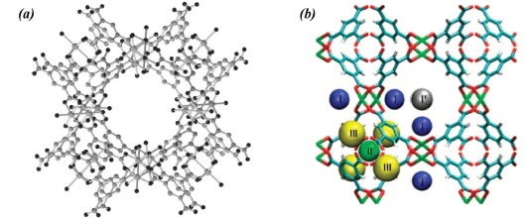

*Figure 1: (a) Structure of HKUST-1 showing the adsorption sites; (b) Ceramic foam; (c) HKUST-1 coated foam.*

* 1. Experimental
     1. Synthesis on ceramic foam

The VUKOPOR® A ceramic foams used are manufactured by LANIK s.r.o (Czech Republic); they are of type 30 PPI (pores per linear inch), like shown in Figure 1b. They were pre-treated with hydrofluoric acid (HF) to remove any impurities that may clog pores and to improve MOF deposition making the surface rougher. In particular, a 5% v/v HF solution was used by leaving the foams immersed in solution for at least 6 hours. After, they were washed with plenty of distilled water and dried in an oven at 100 °C for at least 12 hours. Weighed both before and after HF pre-treatment, a mass loss never exceeding 8% was recorded.

The synthesis of the metal-organic material on foams was performed at 110°C at different residence times. In particular, two solutions were prepared by stirring them at room temperature for 30 minutes (Assche et al., 2012):

• Solution A: contains 6,521 g of copper nitrate dissolved in 60 g of water;

• Solution B: contains 3.218 g of BTC with 47.550 g of ethanol.

After of homogenization, the solution B is slowly poured into the solution A and stirred for another 30 minutes. Each autoclave, where there was a pre‑treated ceramic foam, have been loaded with about 25 g of the final solution. Hydrothermal synthesis was carried out inside the autoclaves, which generally takes place in a temperature range between 110 and 240 °C and at high pressures that increase as the temperature increases. The hydrothermal crystallization method is particularly suitable for the growth of crystals with good quality while maintaining control over their composition. After the time necessary for crystallization, the autoclaves were cooled in cold water and the products obtained were recovered by filtration. Once separated, the powdered MOF and the coated ceramic foam were dried (see Figure 1c) and then characterized. Two types of synthesis were carried out at different residence times in the autoclave: a single and a double synthesis.

* + 1. Characterization of samples

X-ray diffraction was used for the qualitative identification of crystalline phases present in powders. The analysis was carried out using Rigaku's MiniFlex-600 instrument. The interval 2θ in which the analysis was conducted is between 0 θ and 30 θ, with a scanning interval of 1 deg/min.Thermogravimetric Analysis (TGA) was performed on samples to determine changes in weight in relation to change in temperature. A derivative weight loss curve can be used to tell the point at which weight loss is most apparent. The TGA was carried out using a Netzsch instrument model STA 409, (Netzsch-‑Gerätebau GmbH, Selb, Germany). The sample amount (10÷20 mg) is subjected to programmed heating in air flow (5 mL/min) between 30 and 800 °C at a heating rate of 10 K/min. In the specific case of Cu-MOFs, the analysis assess the temperature at which the material undergoes disintegration and rupture and the associated weight loss.

Pore analysis was carried out using the Micromeritics 3-Flex Surface Characterization equipment (Micromeritics, Norcross, GA, USA). The material is heated and degassed, placing it in a vacuum. Controlled amounts of nitrogen is introduced into the vacuum environment at pressure changes over a wide range of values to generate adsorption and desorption isotherms.

A scanning electron microscopy (SEM) was carried out by a FlexSEM 1000 II, (Hitachi, Japan). It provided information on the morphology, size of the crystals, any surface anomalies and chemical composition of the materials analysed. The micrographs were acquired in low-vacuum conditions (50 Pa) from BSE signal and in high vacuum conditions from SE detector.

Finally, adsorption tests were carried out in a column hosting the MOF-impregnated foams. The column used for CO2 adsorption is made of Teflon, with an internal diameter of 3 cm and height 9 cm. The gas flowrates are regulated by a set of two mass flow controllers covering the range 0 ÷ 6000 NL/h. The CO2 concentration in the gas feed stream was adjusted by adding CO2 from a cylinder to the air supplied by a compressor. A system for humidity abatement, made of a column filled with zeolites and activated carbon, is located before the CO2 mixing point. The total pressure drop across the solid bed was measured by a U-tube water manometer. At the upper end of the column there is a branch for inserting the outgoing current composition analyser. The CO2 concentration in the gas stream entering or leaving the adsorption unit was measured by a gas analyser GA-21 plus (Madur Polska Sp. z o.o., Zgierz , Poland) and acquired on a PC. The conditions for all adsorption experiments were ambient temperature and pressure.

* 1. Results

At the end of the synthesis, the resulting samples were filtered and washed with distilled water, obtaining the coated foams and the HKUST-1 powdered product, which were then placed in the oven at 100°C for 20 hours. In the following table the percentages of MOF attached on the foam after one step and after two steps of synthesis are reported. From these data in Table 1, it is evident that the result of the first coating was really variable from a value of 5 to 20% (wt) of MOF deposited and the second deposition operation add small quantity of MOF on foam and can even be counterproductive. In fact, for the A1 autoclave there is a loss of weight, to be attributed to detachment/leaching of the MOF from the surface of the foam caused by impacts with other particles during agitation.

Table 1: Data of HKUST-1 synthesis on foam

|  |  |  |  |  |  |  |
| --- | --- | --- | --- | --- | --- | --- |
| Autoclave | Masssolution  [g] | Massfoam  [g] | Mass(foam+MOF)  [g] \*first step | %MOFcoating  [%] \*first step | Mass(foam+MOF)  [g] \*2nd step | %MOFcoating  [%] \*2nd step |
| A1 | 25.8 | 4.530 | 4.789 | 5.72 | 4.719 | -1.46 |
| A2 | 26.1 | 5.037 | 6.024 | 19.59 | 6.185 | 2.67 |
| A3 | 25.4 | 4.993 | 5.364 | 7.43 | 5.606 | 4.51 |
| A4 | 25.2 | 4.587 | 5.142 | 12.10 | 5.438 | 5.76 |

* + 1. Characterization results

The diffractograms of HKUST-1 powder and MOF-impregnated foam are shown in Figure 2a. There are three main peaks of the MOF: 9.5°, at 11.6° and at 13.4° 2-theta. Peaks at 25.9 and 26.3° 2-theta are attributed to foam. By comparing the intensities of the peaks with those of the coated foam, it is possible to verify that the MOF phase has grown on the foam.



**(a)**

**(b)b**

Figure 2: (a) XRD pattern of HKUST-1 coated foam and HKUST-1 powder; (b) TGA curves for foam before and after MOF-coating and for HKUST-1 powder at 10K/min heating rate.

In Figure 2b are shown TGA curves of the foam before and after coating with MOF and that of the MOF powder: the foam is thermally stable over the considered temperature range. On the other hand, MOF powder and coated foam show two similar variations in weight: between 30 and 100°C there is a loss in weight due to the physical desorption of water; at a temperature of about 300°C weight decreases sharply, where the BTC combustion occurs (with consequent destruction of the microporous structure). This temperature is considered the thermal limit of use for the MOF.

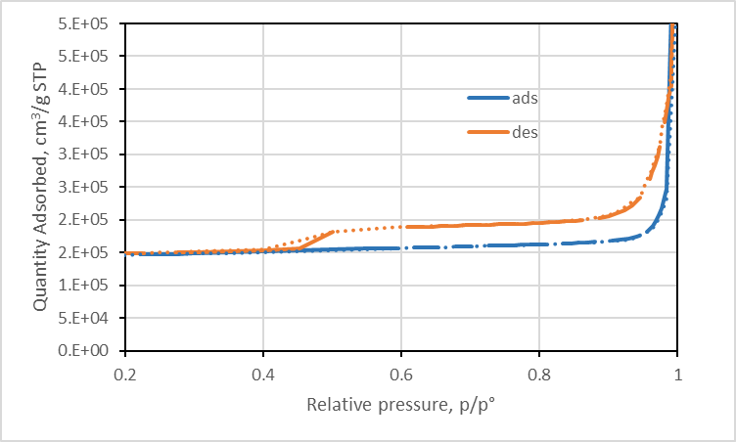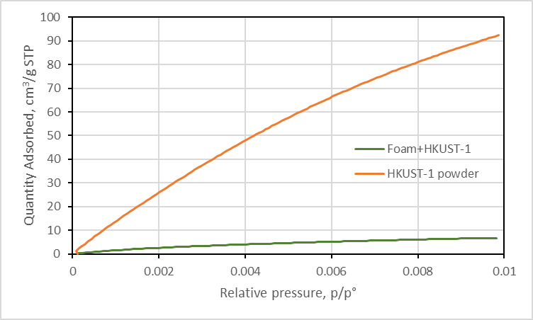

**(b)**

**(a)**

Figure 3: (a) N2 adsorption isotherm for HKUST-1coated foam; (b) CO2 adsorption isotherm for HKUST-1 powder and coated foam.

The N2 adsorption isotherm (Figure 3a) shows hysteresis during the desorption cycle, which suggests the presence of external microporosity due to the foam structure. A BET surface area of 41.4051 ± 0.9760 m²/g has been determined. The MOF synthesized on the surface of the ceramic foam maintains its CO2 capture capacity even if decreased by one order of magnitude respect to that of the powder, (Figure 3b).

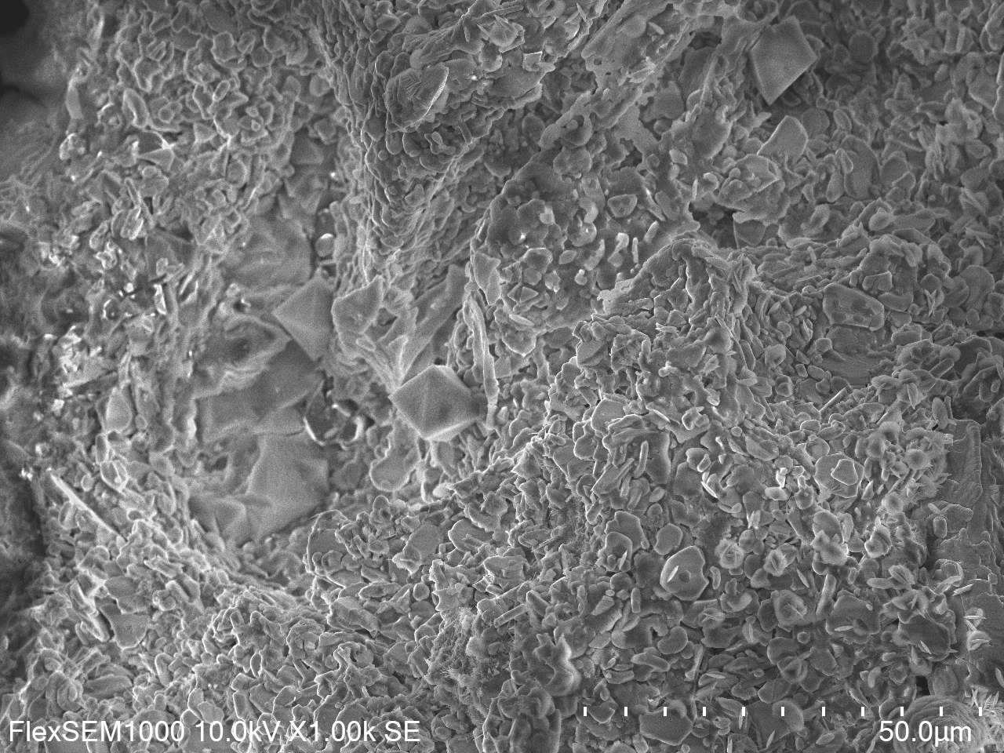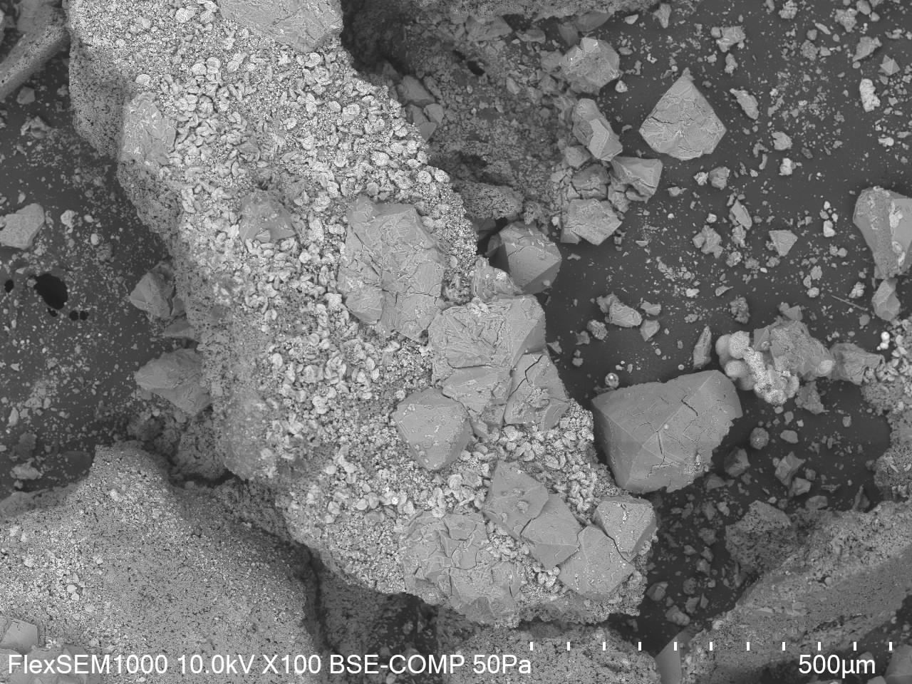

Figure 4: SEM images of HKUST-1coated foam.

Looking at the micrographs shown in Figure 4, some crystals with a shape of a double pyramid with a square base are visible, the size of the crystals varies between 20 and 200 μm; moreover, several impurities are evident; in particular, copper oxide (CuO and Cu2O) similar to diskettes. The formation of such impurity may be due to the excess of Cu2+ compared to BTC, used in the synthesis: in fact, the Cu2+/BTC ratio of 1.80 has been used while the stoichiometric ratio is 1.50. Larger crystals have surface defects probably caused by their high growth rate, while, the smallest ones are almost perfectly formed and without surface defects.

Before the adsorption tests, the pressure drops along the adsorption column, filled with 10 ceramic foams were evaluated: the measurements were made by varying the flow rate of the air fed and detecting the increasing of the pressure by means a water-manometer. The trend shows a quadratic dependence on the gas superficial velocity, represented by equation (1):

|  |  |
| --- | --- |
| $\frac{∆P}{H}=\left(0.0067 u^{2}+0.049 u\right)$ Pa/cm | (1) |

where u is the gas velocity in cm/s. It is confirmed that a multi-foams system structured for capturing CO2 needs really low pressure.

* + 1. Adsorption results

Continuous adsorption tests were carried out at low flow rates of an air/CO2 mixture (with 10% di CO2), to control contact times and avoid detachment/entrainment of MOF particles away from the foam into the gas. In particular, 115 NL/h (32 cm3/s) of air and 20 NL/h (6 cm3/s) of CO2 were used. The outlet CO2 concentration measurements allow obtaining breakthrough curves (see Figure 5) and their parameters: the breakthrough time, the saturation time, the fraction of bed used at the breakpoint, and the adsorption capacity measured as mg of CO2 per g of sorbent (Girimonte et al., 2017).

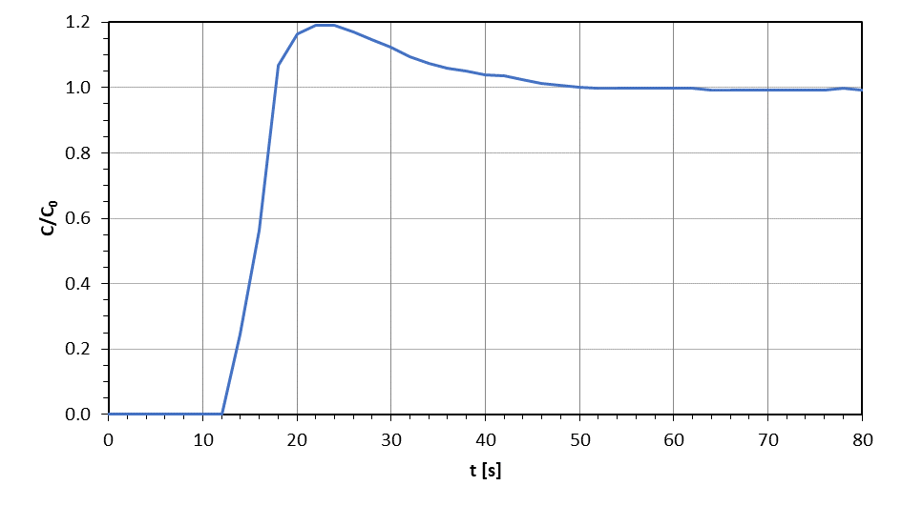

*Figure 5: Breakthrough curve at a fixed concentration of CO2 (10%) for HKUST-1 coated foam.*

This curve shows a CO2 capture capability, quantified at 0.40 mmol/gMOF, similar to results obtained by Xu et al., 2016. The characteristic times, that are the points corresponding to 5 and 95% of the initial CO2 concentration, were respectively of 12 and 18 seconds. The rapid rise from breakthrough to saturation time suggests that all the material has been effectively engaged in CO2 capture, with virtually no diffusive resistance. The coated foam after the adsorption test was regenerated in the oven at 110°C for at least 4 hours and then carried out a further adsorption test, confirming the same performance.

* 1. Conclusions

The synthesis and deposition of MOF HKUST-1 on macro-porous solid matrix allows to obtain a valid device for CO2 capture applications: the adsorption capacity obtained is comparable to results of the literature.

In particular, the HKUST-1 coated foams obtained have been characterized to evaluate the deposition through X-ray analysis, thermogravimetric, nitrogen adsorption/desorption (pores analysis), electron scanning microscopy (SEM) and used for adsorption test with mixture CO2-air at 10%. Every analysis conducted verified the successful deposition of the MOF, demonstrating its uniform distribution across the support's surface and characteristics that are consistent with those reported in existing literature. Furthermore, the fixed bed system, which features layers of coated foams, exhibits minimal pressure drops, a critical requirement for industrial applications. Another important feature of the adsorbent devise is its easy reactivation at temperatures of 110 ºC which does not compromise the adsorption capacity of MOF.

Acknowledgments

The authors gratefully acknowledge Mrs Elisabetta Bruno for the SEM analysis carried out on the samples.

References

Assche T.R.V., Desmet G., Ameloot R., 2012, Electrochemical synthesis of thin HKUST-1 layers on copper mesh, Microporous and meso porous Materials 158, 209-213.

Girimonte R., Formisani B., Testa F., 2017, Adsorption of CO2 on a confined fluidized bed of pelletized 13X zeolite, Powder Technol. 311, 9-17.

Kang Z., Fan L., Sun D., 2017, Recent advances and challenges of metal-organic framework membranes for gas separation. Journal of Materials Chemistry A 5, 10073-10091.

Lan X., Tans P., Thoning K.W., 2024: Trends in globally-averaged CO2 determined from NOAA Global Monitoring Laboratory measurements. https://doi.org/10.15138/9N0H-ZH07.

Modak A. and Jana S., 2017, Advances in Porous Adsorbents for CO2 Capture and Storage, Chapter In: I. Karamé, J. Shaya, and H. Srour (Eds.), Carbon Dioxide Chemistry, Capture and Oil Recovery, IntechOpen. https://doi.org/10.5772/intechopen.70796.

Najafi Nobar S., 2018, Cu-BTC synthesis, characterization and preparation for adsorption studies, Materials Chemistry and Physics 213, 343-351.

Ren J. and Jen. T.-C., 2021, Atomic layer deposition (ALD) assisting the visibility of metal-organic frameworks (MOFs) technologies, Coordination Chemistry Reviews 430, 213734.

Trickett C.A., Helal A., Al-Maythalony B.A., Yamani Z.H., Cordova K.E., Yaghi O.M., 2017, The chemistry of metal-organic frameworks for CO2 capture, regeneration and conversion. Nature Reviews Materials 2, 17045.

Xu F., Yu Y., Yan J., Xia Q., Wang H., Li J., Li Z., 2016, Ultrafast room temperature synthesis of GrO-HKUST-1 composites with high CO2 adsorption capacity and CO2/N2 adsorption selectivity, Chemical Engineering Journal 303, 231-237.

Yu C.-H., Huang C.-H., Tan C.-S., 2012, A review of CO2 capture by absorption and adsorption. Aerosol Air Qual. Res. 12, 745–769.

Sofia, D. ; Gioiella, F.; Lotrecchiano, N.; Giuliano, A., 2020, Cost-benefit analysis to support decarbonization scenario for 2030: A case study in Italy. Energy Policy, 137.

**Nomeclature**

BET Brunauer–Emmett–Teller method used to determine the specific surface area

BTC benzene-1,3,5-tricarbocylate

CCSU Carbon Capture and Storage or Utilization

MOF metal-organic frameworks

POP porous organic polymers

SEM electron scanning microscopy

TGA thermo-gravimetric analysis

ZIP zeolitic imidazolate frameworks